GTPlot Revision History

Here is a list of revisions made to GTPlot over the years.

Contents

09.42+ Enhancements 2

Software 2

Enhancement 2

10.00.0000 Enhancements 2

Software 2

Enhancement 2

10.01.0000 Enhancements 3

Software 3

Enhancements 3

API reference changes 3

Documents 3

New GT_PLOT_PARAMETER table 5

Plot Boundary Info View 5

Product Legend Metadata Changed 6

OLE Object Insertion 6

User Defined Plot – Preview 7

Know Issue 7

10.01.0001 Enhancements (v1.4) 7

10.01.0001 Enhancements (v1.5) 8

Print Active Map Window Custom Command 8

Known Functional Issues 9

10.01.0001 and 10.02 Enhancements (GTPlot_v1.7.0.18) 9

Future Enhancements 10

Plot Boundary Placement by Grid 10

Generating a new Plot Window 10

More Future Enhancements 10

# 09.42+ Enhancements

## Software

5 separate VB.NET solutions ported over from VBA. They are categorized as follows:

* Plot Boundary Placement
  + PlotBoundaryIPT (Placement Technique)
  + PlotBoundaryIPT_FI (Functional Interface)
  + PlotBoundaryLabelSPT (Silent Placement Technique)
* Generating a new Plot Window
  + New Plot Window (Custom Command)
* Managing Workspace Plots
  + Workspace Plots (Custom Command)

## Enhancement

I think that only the Industry Ware Comms Model and Fortis are using versions of this.

1. Ported from VBA to VB.NET
2. Added support for many business requirement driven by Fortis.
   1. Legend Overrides.
   2. Style Substitution support.
   3. Support for Multiple template styles.
   4. Many more…

# 10.00.0000 Enhancements

## Software

The source code in this version was merged into a single GTPlot solution.

## Enhancement

1. Support for inserting object. Enhanced the GTPlotBoundaryIPT and GTNewPlotWindow commands and GT_PLOT metadata to support the automatic insertion of OLE objects.
2. Support for Plot Type driven Page Size, Page Orientation and Scale. Enhanced the GTPlotBoundaryIPT and GTNewPlotWindow commands and GT_PLOT metadata to support Scales driven from plot type, page size and orientation. Added GT_PLOT_DRAWINGINFO.DRI_SCALES to store the allowable scales per sheet.
3. Renamed APL_* tables to GT_PLOT_*
4. Placed all hard coded tables, columns references etc. into a resource file.
5. Enhanced the GTPlotBoundaryIPT and GTNewPlotWindow commands and GT_PLOT metadata to support a special Key Map mapframe.
6. Support for optional borders. Added optional frame inset, moved inset and inset style to drawing info table so that they can be optionally defined per drawing type.
7. Many bug fixes.
8. More…

# 10.01.0000 Enhancements

## Software

Contained in the latest GTPlot solution **GTPlot/iw_gtplot (padams1 v1.4).zip**

This code was compiled in VS2008 with 0 errors and 0 warnings reported.  If you are having reference problems please take a look at the References.txt file under the Documents folder in the solution.

## Enhancements

1. Implemented new product API references.
2. Now storing all documents and SQL scripts within the solution.
3. All configurable parameter have been moved out of the code and resource files and into the database.
4. Plot Boundary Info View added - The view is used by the NewPlotWindow custom command to retrieve all of the column info required to generate the redline text. VGC_WRKBND_PLOT
5. Added support for product’s changes to the Legend metadata.
6. OLE Object Insertion -Added the ability to have an OLE Object automatically inserted into a plot window.
7. Added Template Preview to User Defined Plot (same one used during placement).

### API reference changes

The G/Technology v10.1 API references have changes some. The GTPlot code base was updated with the require changes.

### Documents

I get asked for database implementation scripts and the latest documents I have all the time, so I’ve added them directly to the GTPlot solution. Anytime you get a new version of the software the latest will exist as part of the solution. Simply look for the new Documents and SQL Scripts folders in the latest GTPlot solution.

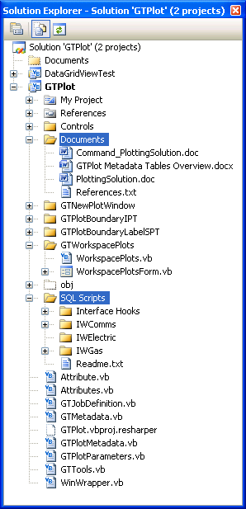The documentation needs some additional work and we currently have 2 version of the PlottingSolution document however there is still a lot of good information in both. Check out the Readme.txt in the SQL Scripts folder for more details on the database metadata. We have sample IWComms and IWGas templates. I haven’t had time to update the IWElectric templates yet.

### New GT_PLOT_PARAMETER table

All configurable parameter have been moved out of the code and resource files and into the database. This was to better facilitate a single code base for the industry ware versions for U&C.

In order to support a single code base for multiple configurations a new table was added to store configuration specific metadata that was previously stored in the code and a project resource file.  This will allow for much easier upgrades without having to update the information in the resource file every time.  The script to create the new table with sample metadata is located in the solution here: …\GTPlot\SQL Scripts\IWComms\GT_PLOT_Tables\gt_plot_parameters.sql

The only item that needs to be in the project resource file now is the name of the **GT_PLOT_PARAMETER** metadata table without an ‘S’ at the end.

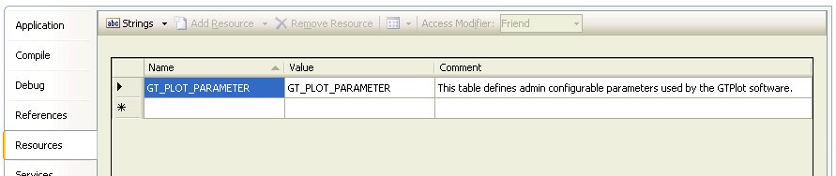

### Plot Boundary Info View

It’s important to verify that your Plot Boundary Info View is configured correctly now that the GTPlot application depends heavily on it.  Verify that the view used by GTPlot to retrieve all of the boundary column info has all the required columns exposed. This view is primarily used to generating the list of available plot boundaries and to expose attribute values used to generate the redline text that exists on your plot. Minimum required plot boundary feature columns are:

* g3e_id
* g3e_fno
* g3e_fid
* g3e_cno -Geo CNO of Plot Boundary Polygon
* g3e_cid -Geo CID for Plot Boundary Polygon
* g3e_detailid -Detail CNO for Plot Boundary Polygon (Optional)
* g3e_cno_d -Detail CNO for Plot Boundary Polygon (Optional)
* g3e_cid_d  -Detail CID for Plot Boundary Polygon (Optional)
* plan_id
* plot_type
* plot_size
* plot_scale
* plot_orientation
* job_name < used to link the feature to an active job.
* [...] < Any attributes required to automatically display as automatic redline text.

Sample of what the where clause might look like with an outer join to the geometries to support only a detail or geo polygon existing:

    FROM   gc_wrkbnd a, gc_netelem b, g3e_job c, dgc_wrkbnd_p e, gc_wrkbnd_p f

   WHERE       b.g3e_fno = 1500

           AND a.g3e_fid = b.g3e_fid

           AND b.job_name = c.job_name

           AND a.g3e_fid = e.g3e_fid(+)

           AND a.g3e_fid = f.g3e_fid(+)

           AND a.plan_id IS NOT NULL

           AND a.plot_orientation IN

                  ('L', 'P', 'Landscape', 'Portrait', 'ADHOC')

           AND (g3e_status IN ('Open', 'PartiallyPosted', 'Posted')

                OR g3e_status IS NULL);

### Product Legend Metadata Changed

Product has added a new legend metadata table. Enhanced the GTPlot legend queries to support using the new legend table.

### OLE Object Insertion

I have added the ability to have an OLE Object automatically inserted into a plot window.

Here is a sample of metadata using bitmap images.  For the moment the path is hard coded but we will need to create some code that will look for file in paths defined in the FileUNCPaths.xml file instead.  I haven’t tried it but all you should have to do is reference a Word or Excel document for OB_FILE and link that to the appropriate GROUP_NO for you plot template.



### User Defined Plot – Preview

Added a plot preview window, this is similar to that shown during placement aiding the user in choosing the correct plot to generate.

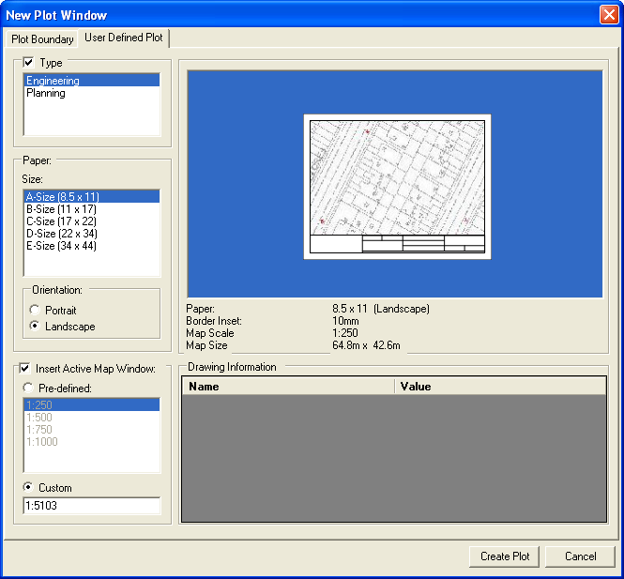

## Know Issue

Open & Close Plots: SR# 1-309503651. This is a bug that should be fixed in G/Tech 10.01- Service Pack 1 that I have not tested yet.  I’ve attached the e-mail from product detailing the CR that fixed it.

# 10.01.0001 Enhancements (v1.4)

No enhancements have been made at this time. Issues have been reported within the IWC model but I have not verified if the issues are simply configuration related. The Open & Close Plots: SR# 1-309503651 AKA(CR-Defect ID: **30364_U**) might also not be fixed yet.

# 10.01.0001 Enhancements (v1.5)

Added PrintActiveMapWindowSettings and PrintActiveMapWindow custom commands and cleaned up minor bugs throughout. Fixed issues with PlotBoudaryIPT dialog defaults restoration.

Issues still exist within Open & Close Plots: SR# 1-309503651 AKA(CR-Defect ID: **30364_U**) when tested on G/Technology v10.01.0001.05003.

## Print Active Map Window Custom Command

The **PrintActiveMapWindowSettings** custom command was added that enables users to print the active map window using an alternative legend. This requirement came primarily from users wanting to work with a black background but needed to print using a white background with alternative inverse geometry colors. A **PrintActiveMapWindow** custom command was also added to quickly print using the last set Paper Size, Paper Orientation and Legend.

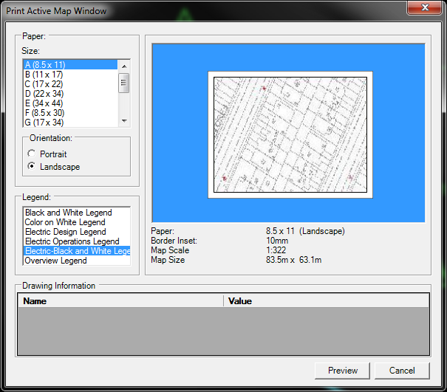

The new commands make use of the GTPLOT metadata and a defined template named “PrintActiveMapWindow”. This allows administrators to configure map window placement along with any additional redline information required. This version has been implemented at Oshawa Hydro.

### Known Functional Issues

Further testing is required to verify the workings of redline text and the use of the Drawing Information data grid along with auto population of Automatic Fields updates like Data, Time, Scale, User, etc. The Drawing Information values should also be persisted.

# 10.01.0001 and 10.02 Enhancements (GTPlot_v1.7.0.18)

Many new enhancements have been added to support Bell Canada moving from their old VBA plotting solution to the new VB.NET GTPlot solution.

The enhancements include:

* This version of GTPlot now supports the auto placement of a formation mapframes grid that exist within a given detail. Added a new gt_plot_formations.sql metadata table to drive auto formation placement.
* Added Constraints to all GT_PLOT_* tables.
* Added Edit_Date column and trigger to all GT_PLOT_* tables.
* Support for Detail drawings.
* Fully localized - multi(2) language support
* Rob added support for multiline text generated from package call.
  + Added new ‘GT_PLOT_TMP_MULTI_TEXT’ in  GT_PLOT_PARAMETER
  + Added a new GT_PLOT_REDLINES. RL_DATATYPE named "Redline Multi Text" where a procedure can be created to generate multiline text.
  + Please see sample package: GET_ARB_NOTES_PKG
* Enhance User Defined Template to support plot info triggering attribute values and sorting.
  + Added GT_PLOT_REDLINES.RL_TEXT_TRIGGERED_BY to support the triggering the auto population of various attributes.
  + Added GT_PLOT_REDLINES.RL_TEXT_ORDINAL to allow changing list sorting.

# Future Enhancements

## Plot Boundary Placement by Grid

No Grid placement functionality yet. I was going to add a Linear placement of grids, selecting a start and end point then automatically fill the space between with predefined Plot Boundaries auto naming/numbering as they are placed.

## Generating a new Plot Window

If you already have a Grid of boundary feature placed it wouldn’t take much to add a drop down pick list to enable showing various types of map polygons in the New Plot Window command’s available list of plots. The pick list filter could have:

* Plot Boundary (Currently filtered by Job and User)
* Cartographic Grid (would likely have no Job and User filter)
* Staking Sheets
* ...

A separate template (Plot Type) could then be defined for each type of boundary.

## More Future Enhancements

Please see the **Future Enhancements** section **PlottingSolution.doc** for addition items.